NAME: SAGARSUMAN P MANJHI SUBJECT: PYTHON PROGRAMMING LAB | PRACTICAL: 10 | BATCH : 04  SYBVOC :SEM-III (DS)
EXPERIMENT BASED ON FILE AND DIRECTORY HANDLING

AIM : To study and implement file handling operations in Python by creating a Personal Expense Tracker that stores expense records in a text file, displays all expenses, calculates total expenditure, counts records, and handles file-related exceptions.
LEARNING OBJECTIVE :
  - To understand file handling operations in Python.
  - To create, write, read, and rename text files.
  - To check whether a file exists using the os module.
  - To count the number of expense records.
  - To determine the file size using Python.
  - To handle file-related exceptions using try and except.
TOOLS :
Sr. No. | Name Of Resources | Specification | Quantity | Remarks
1. | Hardware | Computer (i5-i7) Ram (Min 16GB) | 1 | For All Practical
2. | Software | Python / IDLE / VS Code | 1 | For All Practical
THEORY :
File handling in Python allows programs to create, read, write, append, rename, and delete files. It is useful for storing information permanently so that data can be accessed after the program finishes executing.
In this practical, a Personal Expense Tracker stores expense records in a text file named expenses.txt. The program checks whether the file exists, renames it to my_expenses.txt, reads the stored records, calculates the total expenditure, counts the records, and displays the file size.

Concepts Used
- File Handling: Operations performed on files to store and retrieve information.
- open(): Opens a file in a specified mode.
- Write Mode (w): Creates a new file or overwrites an existing file.
- Read Mode (r): Reads data from an existing file.
- with Statement: Manages the file resource and closes it automatically after the block finishes.
- os Module: Provides functions for file and directory operations.
- os.path.exists(): Checks whether a file or directory exists.
- os.rename(): Renames a file or directory.
- os.path.getsize(): Returns the file size in bytes.
- Exception Handling: Uses FileNotFoundError and OSError to handle file-related errors.
- String Processing: Uses strip() and split() to process expense records.

Source Code:
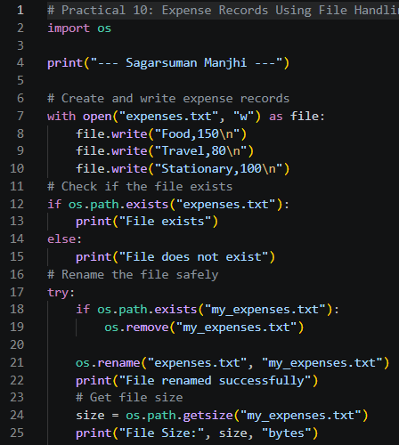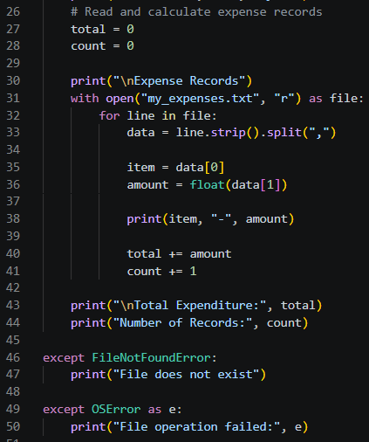
Output:
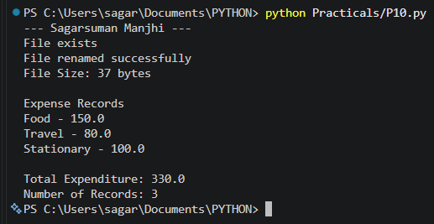
Result and Discussion:
The Personal Expense Tracker was implemented successfully using Python file handling and the os module.
The program creates a text file containing three expense records: Food, Travel, and Stationary. It checks whether the file exists, renames it, calculates its size, and reads the records to determine the total expenditure and number of records.
The total expenditure is ₹330, calculated as ₹150 + ₹80 + ₹100. The program displays three expense records and reports the file size as 37 bytes for the given text content.
Exception handling is implemented using FileNotFoundError and OSError to handle common file-related errors.

Note: The program uses write mode (w), so each execution recreates expenses.txt and overwrites its previous contents. It also removes an existing my_expenses.txt before renaming the new file.
Learning Outcomes:
- Learned to create and write data to text files.
- Used the os module to check file existence, rename files, and obtain file size.
- Learned to process text records using string methods.
- Calculated total expenditure and the number of records.
- Applied exception handling to manage file-related errors.
Course Outcomes:
- Understand file handling operations in Python.
- Apply file and directory operations using the os module.
- Process stored data and perform calculations using file contents.
- Handle file-related exceptions to improve program reliability.
CONCLUSION :
The Personal Expense Tracker was developed successfully using Python file handling and the os module. The program stores expense records in a text file, checks file existence, renames the file, calculates its size, displays the expenses, and computes the total expenditure and record count. This practical demonstrates how files can be used to store and process information in Python.

VIVA QUESTIONS :
Q1. What is file handling in Python?
File handling is the process of creating, reading, writing, and managing files using Python.
Q2. Which function is used to open a file?
The open() function is used to open a file.
Q3. What is the difference between w and r modes?
The w mode writes data and overwrites existing content, while the r mode reads existing data.
Q4. What is the purpose of the with statement?
It manages the file resource and automatically closes the file when the block finishes.
Q5. What is the purpose of the os module?
It provides functions for interacting with the operating system, including file and directory operations.
FOR FACULTY USE ONLY :
Correction Parameters | Formative Assessment [40%] | Timely completion of practical [40%] | Attendance/ Learning Attitude [20%]
Marks Obtained

